Practical Exam   
Subject: WED201c  
Duration: 120 minutes

**Objectives:**

1. Create a Cascading Style Sheet (CSS) and link it to the HTML files. **(Without changing the html)**

2. Create a javascript file (js) and link it to the HTML files. **(Without changing the html)**

**Background:**

In this practical exam, you are going to use some files in the **Resource folder** to finish the exam.

**Before styling portfolio.html page**

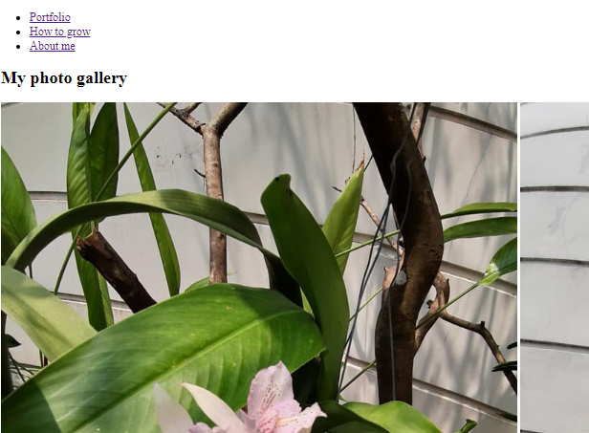

**After styling portfolio.html page  
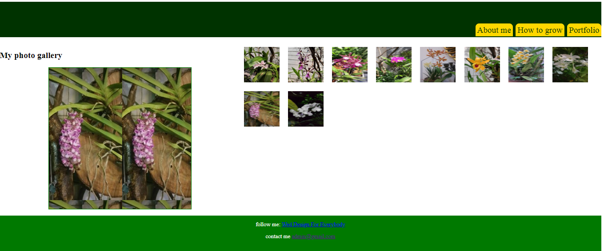**

**After styling howtogrow.html page**

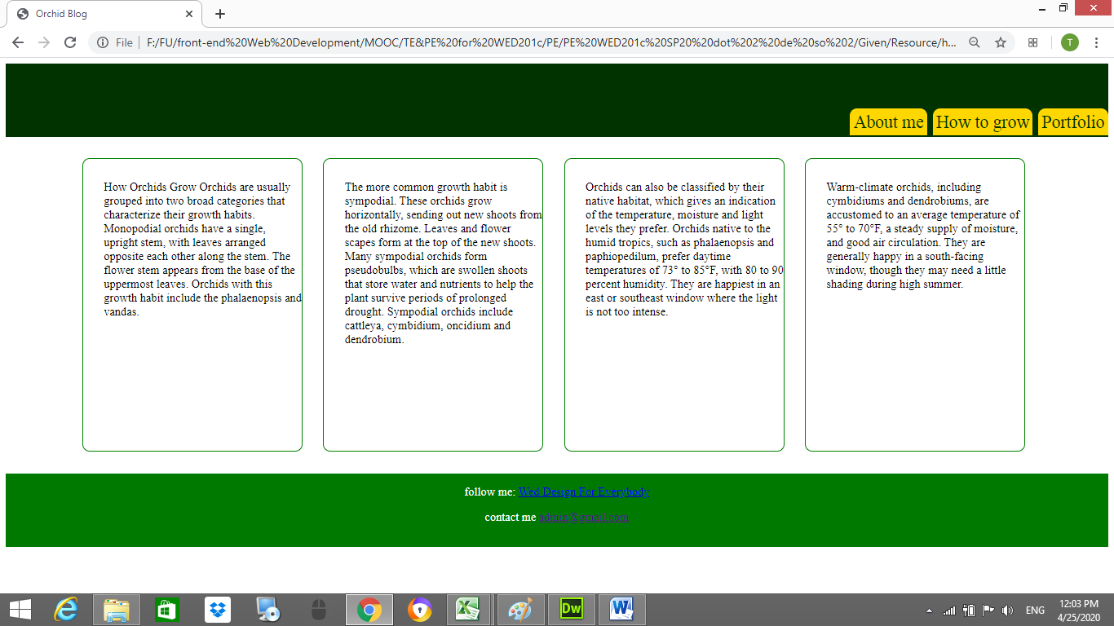

**After styling aboutme.html page**

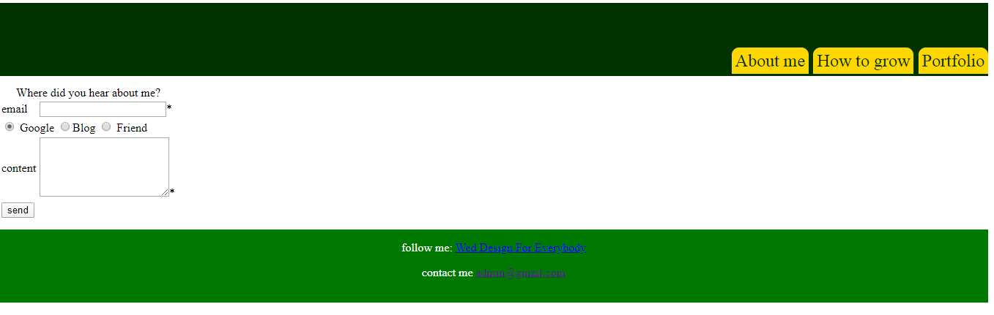

**Requirements:**

1. Create a file called **portfolio.css** and save it in a given **Resource/css folder.** In this file you can use any css properties to style some html pages. You can view the styled pages in folder “**Template**”
2. Create a file called **portfolio.js** and save it in a given **Resource/js folder.** In file **portfolio.js,** using javascript to create a kind of photo gallery and validate a form.
   1. Write a function **changeImg ()** to change the background image of tag div(file portfolio.html) when you move your mouse on the small image; This function has one input parameter (input parameter is the hovered small image ). This function changes the background image of the div(id=" bigImg ").
   2. Write a function **check ()** to validate the form (file aboutme.html) when a user clicks the button “send”.

* Change the background color of the field to RED if its value is empty.
* If email and content fields are not empty, the page shows a message that includes email, choice, content.

When submitting your result, please submit the **whole folder** includes **all your files and sub-folders but not just only CSS file and js file**.

**Evaluation:**

**CSS: 5 points**

1. Header, section, and footer tags do not overlap? **[0.5point]**
2. Links in the header tag are floated to the right and the bottom of its container **[0. 5 point]** and decorated with any text color, background- color, none underline. **[0.5 point]**
3. The section tag (class=”left”) is aligned to the left of its container and the section tag (class=”right”) is aligned to the right of its container (file portfolio.html)? **[0.5 point]**
4. All small images do not overlap and you should keep spacing around them **[0.5 point]**
5. All texts in the footer tag should are styled to look like the sample **[0.5 point]**
6. All paragraphs in section tag in “howtogrow.html” page should be divided into 4 columns **[0.5 point]** and these columns are decorated with border properties, aligned to the center and keep spacing around them**[0.5 point]**
7. When you move your mouse on the p tag in “howtogrow.html”, text-color of this p tag will is changed to another color (using CSS, not javascript) **[1 point]**

**Java script: 5 points**

1. The function **changeImg** is correctly **[2 points]**
2. The function **check()**
   1. Change the background color of the field to “RED” if its value is empty. [1 point] (only evaluate on email and content)

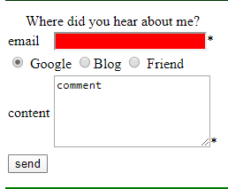

* 1. If email and content fields are not empty, the page shows a message that includes email, content [1 point], and choice [1 point].

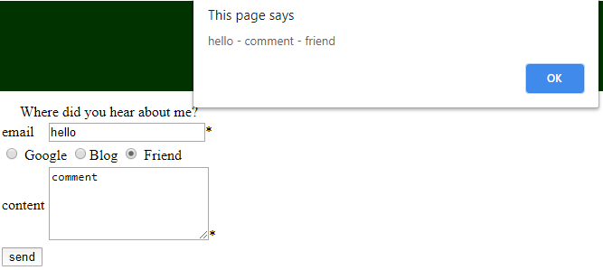

**Total: 10 points**

**(Students do not change the path of all files in Resource folder)**

The End